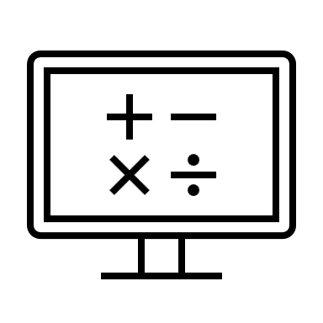

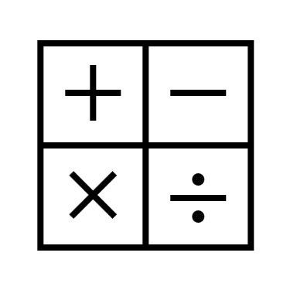



***~MAGIC GAME BOX~***

* Visual Programming Project -

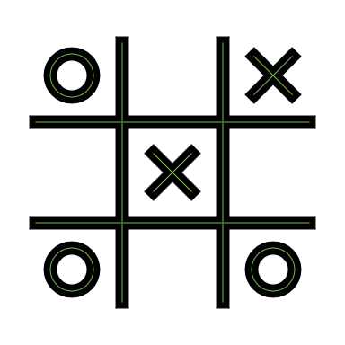******

Project developed by:

Name: Larisa-Maria NICOLA

Year: 3

Group: 4.2

***Content***

1. Magic Game Box -Motivation of the solution ....pag.1
2. Visual Model Presentation ...................................pag.4

* Tic Tae Toe......................................................pag.5
* Math Quiz.......................................................pag.7
* Sudoku............................................................pag.10
* 2048 Game......................................................pag.15
* Memory Game................................................pag.17

1. Presentation of how to use the application .......... pag.19

* Tic Tae Toe..................................................... pag.20
* Math Quiz.......................................................pag.21
* Sudoku............................................................pag.23
* 2048 Game......................................................pag.25
* Memory Game................................................pag.27

1. References ............................................................pag.29
2. **Magic Game Box –Motivation of the solution**

**Magic Game Box** is a game developed for the "Visual Programming" course by third-year student Larisa-Maria NICOLA.

The application I developed includes a carefully selected set of 5 mini-games: Tic Tac Toe, Math Quiz, Sudoku, 2048 Game, and Sudoku.

These games are designed to provide users with a captivating and accessible experience. The motivation behind this solution was guided by the desire to offer a variety of games, an intuitive and easy-to-navigate interface, so that any user, regardless of their experience level, feels comfortable exploring and using the application.

The selected games cover a wide range of user preferences. Their purpose is to satisfy both the desire for recreation and education, offering users both entertainment and learning activities.

Each game has been integrated to provide a unique experience, from the logical challenges of Sudoku to the interactive fun of Tic Tac Toe (also known as "X and O").

Symbols and colors were carefully chosen to enhance the understanding of functionalities and to create a visually pleasing experience.

I integrated visual and auditory feedback during the use of the application to inform users about their actions and to create a richer interactive experience.

1. **Visual Model Presentation**

The presented application was created in **MIT App Inventor**.

MIT App Inventor is a mobile application development platform developed by the Massachusetts Institute of Technology (MIT). This platform provides a visual and easy-to-understand programming environment, designed to allow anyone to create mobile applications without requiring extensive programming knowledge.

The interface is user-friendly, allowing users to build applications by dragging and dropping code blocks, eliminating the need to write code manually.

Applications created with MIT App Inventor can run on both Android and iPhone devices.

The platform includes support for a wide range of sensors and mobile device functionalities, enabling developers to create interactive and complex applications.

Next, I will present some of the functionalities of my project.

* **Tic Tae Toe**

This game contains a **label** that indicates the player's turn. The game board consists of **6 buttons**, and there are **4 additional buttons** with the following functionalities: **Reset**, **Score**, **Erase Score**, and **Choose Another Game**.

When the game is initialized, the score information is retrieved, and then a new game is started by resetting the button layout using a procedure.

Then the buttons are set:

The onceClicked procedure is used to set the game board, and by calling the hasWon procedure, it is checked whether someone has won or it is a draw.

The Reset button is used to reset the game board.

The Score button will display the list of previous winners, and the EraseScore button will delete that list.

The last button, Choose another Game, has the functionality of returning to the page where the list of games is located.

* **Math Quiz**

This game is designed to test your math knowledge. It has 3 levels.

**-Level 1-**

The first level consists of answering as many questions as possible correctly, to achieve the highest possible accuracy, which will be saved.

We will have a timer and two boxes where the number of correct and incorrect answers will be counted.

Addition and subtraction questions will appear in a label, and the answer will be chosen from a block. Their order, as well as the answer options, will be randomly generated.

We also introduced sounds representative of a correct or incorrect answer.

The application also contains a Help button, which will open a calculator, and a Quit button that returns you to the game list page.

When the time is up, your accuracy will be calculated and checked to see if you have exceeded your best accuracy.

**-Level 2-**

It is similar to Level 1, except that multiplication and division operations are added and the range of operand selection is larger.

**-Level 3-**

In this level there are no answer options, but it is entered in a text box.

Both the operation and the numbers will be taken randomly.

When the game is initialized, the information regarding the best accuracy will be retrieved and the timer will start.

* O imagine care conține text, captură de ecran, număr, Font

  Descriere generată automat**Sudoku**

The application contains a label, which indicates which version of the game it is, currently we have only implemented 2, which will be chosen randomly when pressing the Reset button via a method.

The game board consists of 9 3x3 (1 to 9) squares (from A to I), made up of buttons.

Below the game board are 9 buttons, which offer the possibility of choosing a number with which to complete the game board, and another button that displays the current selection.

A list of buttons was created for each table, in which the text content of each button will be saved.

For each option, we created lists with the correct answers, which will need to be entered by the user.

When the application is initialized, the timer is started and the game board is created, via the MakeGrid procedure.

The ResetTotal procedure clears all text from all buttons and sets TextColor to black, and the GlobalVariableTo0 procedure sets variables that indicate whether a button can change or not to 1.

The game variant will be chosen randomly, and the actual setting of the board is done through the SetGridVar1 or SetGridVar2 procedures.

These procedures set the buttons that will contain text, differentiating them from the others by having purple text.

The application also contains the Check button, which checks the contents of the board.

For the game to be checked, it must not contain buttons without text, which is checked by Check_Blank, which sets a global variable to 0 if there are buttons without text.

If text has been entered in all buttons, the CheckResultVar procedures will check each element in the entered list with each element in the list of correct answers.

If an answer is wrong, the text color will change to red, otherwise, to green. This helps the user understand what they did wrong.

* **2048 Game**

This page contains a label where the current score is entered, calculated as the sum of the numbers that end up being identical next to each other, and another label where the highest score is entered.

When the page is initialized, the highest score is read.

The game board consists of a Canvas, into which we have inserted 16 ImageSprites.

The 16 ImageSprites can be moved in 4 directions: up, down, left, right, the movement effect being implemented through 4 methods.

The images that make up the game board are selected randomly, using a procedure.

The page also contains a Reset and Quit Game button.

If the board is full, and no more moves can be made, the message Game Over will appear.

* **Memory Game**

This game consists of creating pairs of images.

It consists of 3 levels.

The application contains a timer that starts from 0, a score, which indicates the number of pairs found, and a label in which the best time obtained is taken.

The game board consists of 6, 8, or 12 buttons, depending on the selected level.

Each button will call the procedure that has the role of "turning" the button and displaying the image, and if it is a pair, it will be fixed on the screen and the button will no longer be accessible.

The application also contains 2 buttons: Start/Reset and Quit.

The Start/Restart button starts the timer, sets the current score to 0, and resets the game board, via the Reset procedure.

The images for each button are selected randomly.

The Quit button will only transmit the best time if the game has been completed, meaning all pairs have been found.

1. **Presentation of how to use the application**

The application has a friendly interface, which helps the user understand how it works.

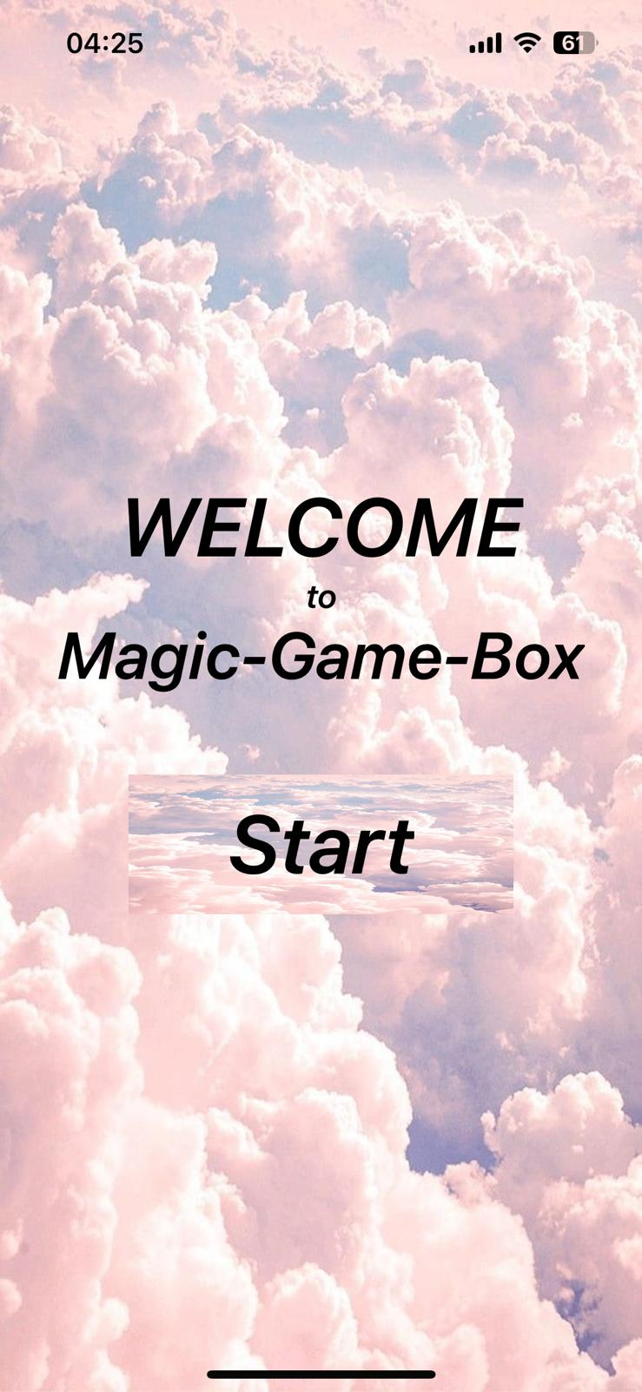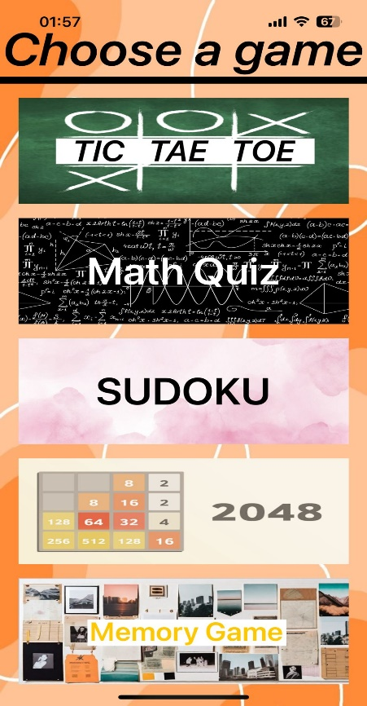When opening the application, the main screen appears, which when pressing the Start button will open the screen containing the list of games.

* **TIC TAE TOE**

When launching the TIC TAE TOE game, the first page will appear, which contains some information about the game. By pressing the Start button, the game will start, or by pressing the Choose another Game button, the user will return to the game list page.

A round is considered won if the same symbol (X or O) appears on a diagonal, row or column, otherwise it will be a draw.

Each player's round is consistently indicated, and depending on the player, the background color of the square in which the information was entered will change.

When you press the Score button, the list of previous winners will be displayed, and when you press the Erase score button, the contents of that list will be deleted. When you press the Reset button, the game board will be reset, meaning the entered items will be deleted.

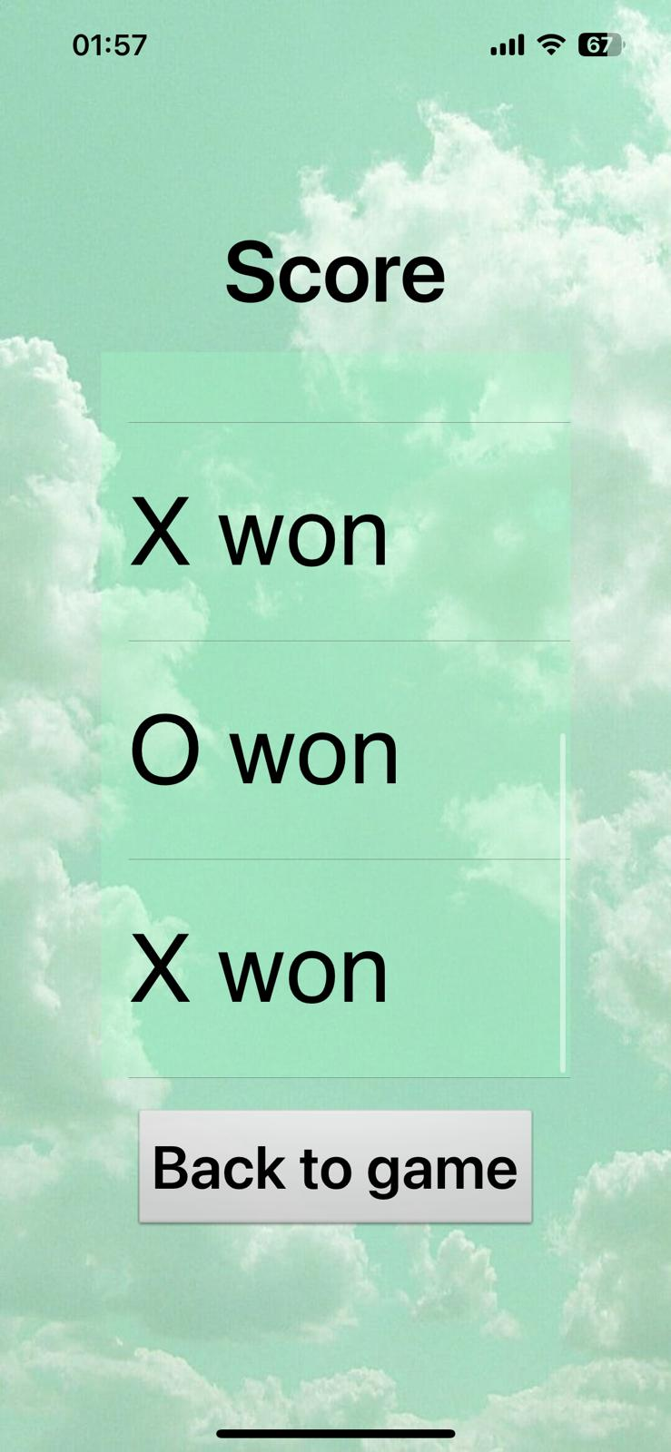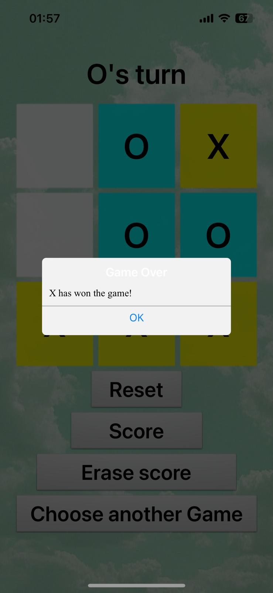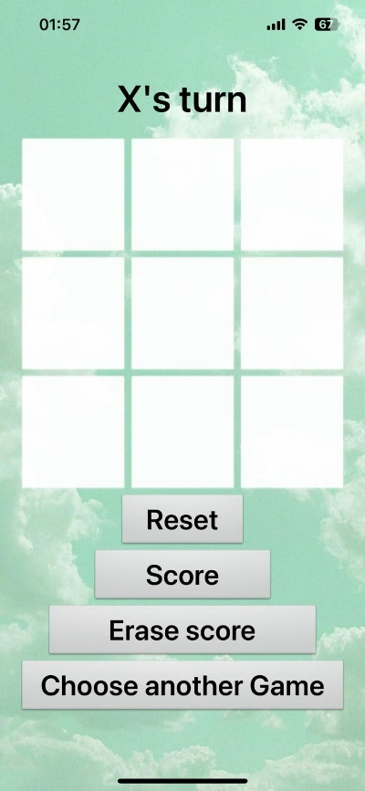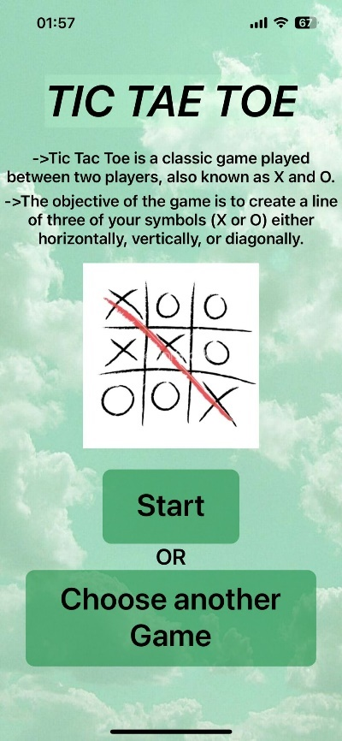If you want to return to the game list, press the Choose another Game button.

* 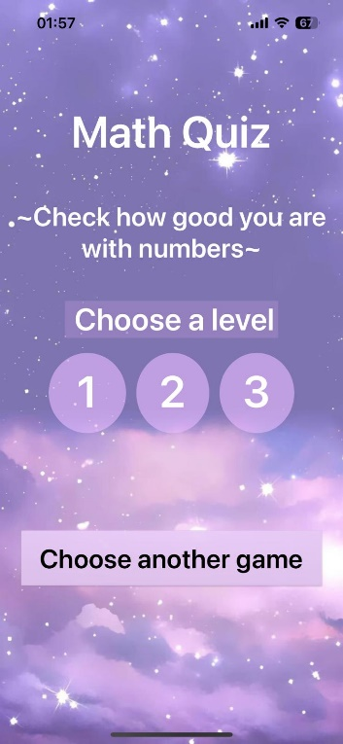**Math Quiz**

This game was designed to test your math knowledge.

The first page contains a brief description, and offers the possibility of choosing a level by pressing buttons 1, 2 or 3. If you want to leave the game, press the Choose another Game button.

Level 1 contains addition and subtraction operations. A 1-minute timer will start, during which the questions must be answered by choosing an answer from the 4 options. If the answer is correct, the number of correct answers will be incremented, otherwise the number of wrong answers. Finally, after the time has elapsed, the accuracy of the game is calculated, and if it is higher than Best accuracy, it will take its place.

When pressing the Restart button, both the timer and the answer counters will be reset, and when pressing the Quit button, a notification will appear, and if the user chooses YES, they will be returned to the Level selection page.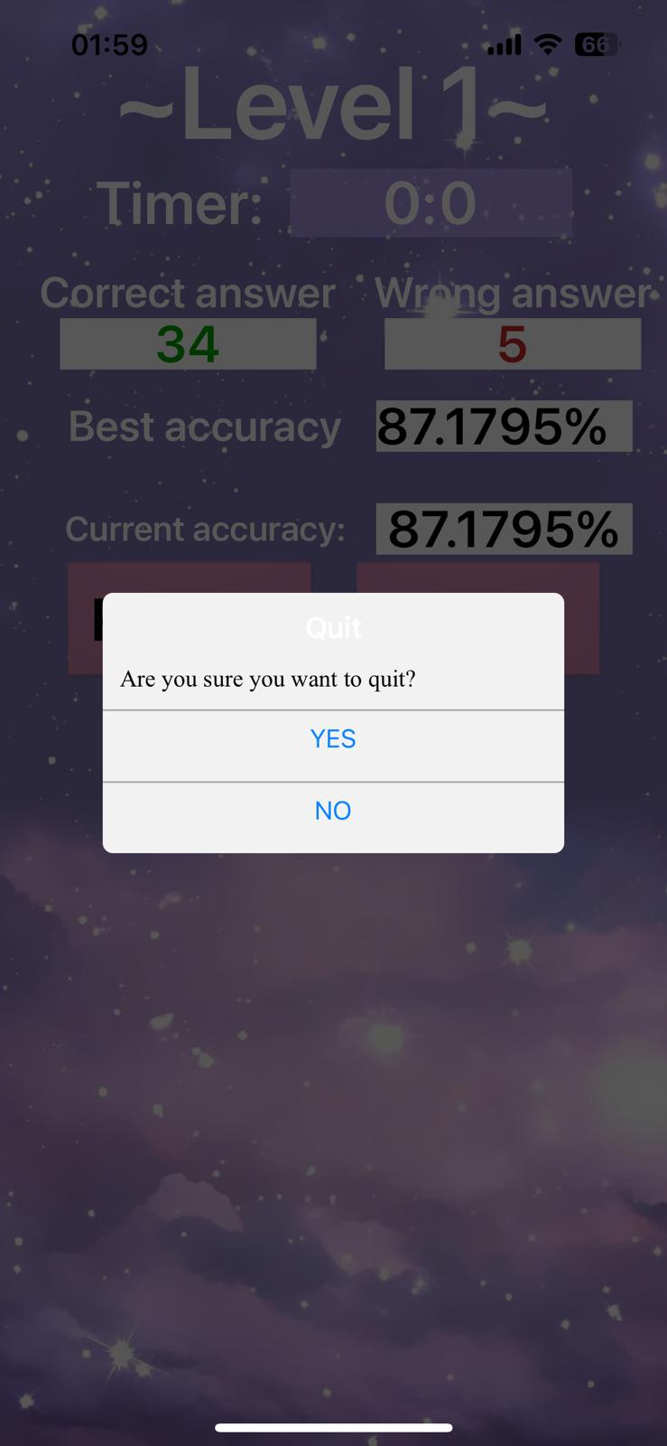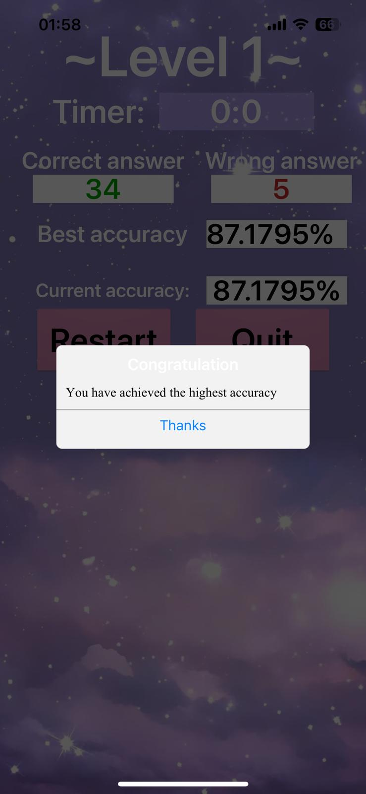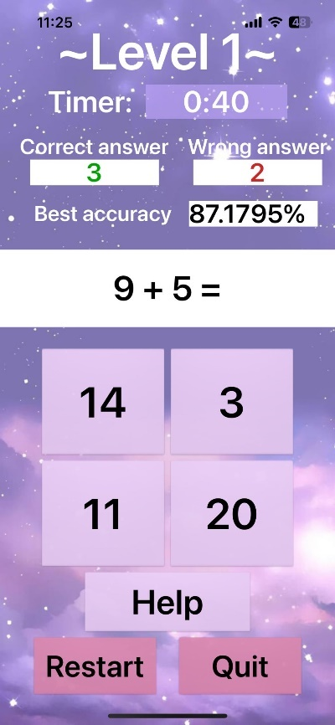

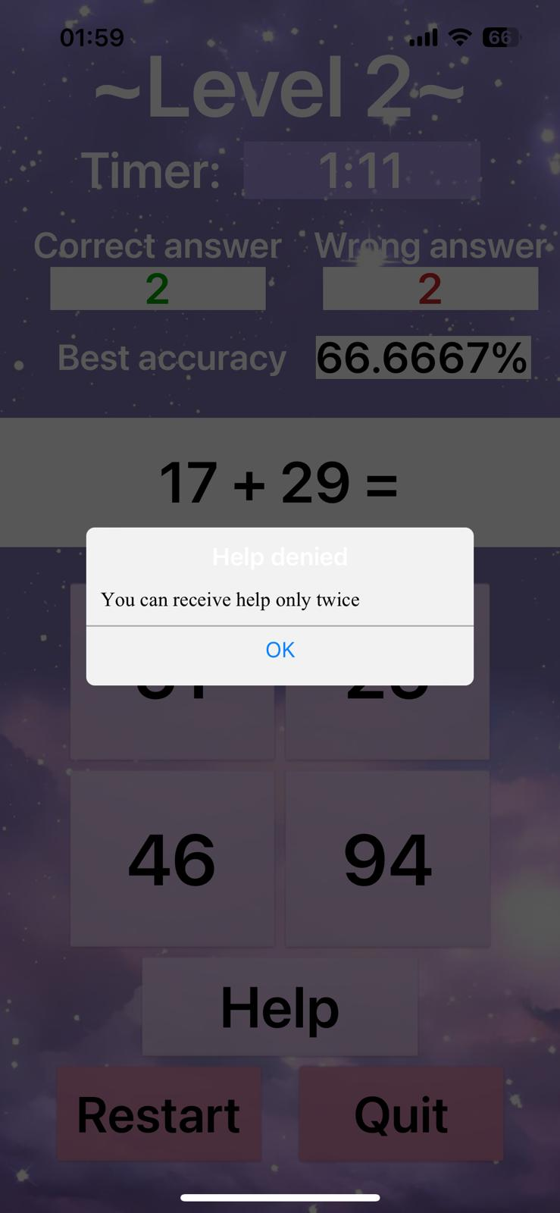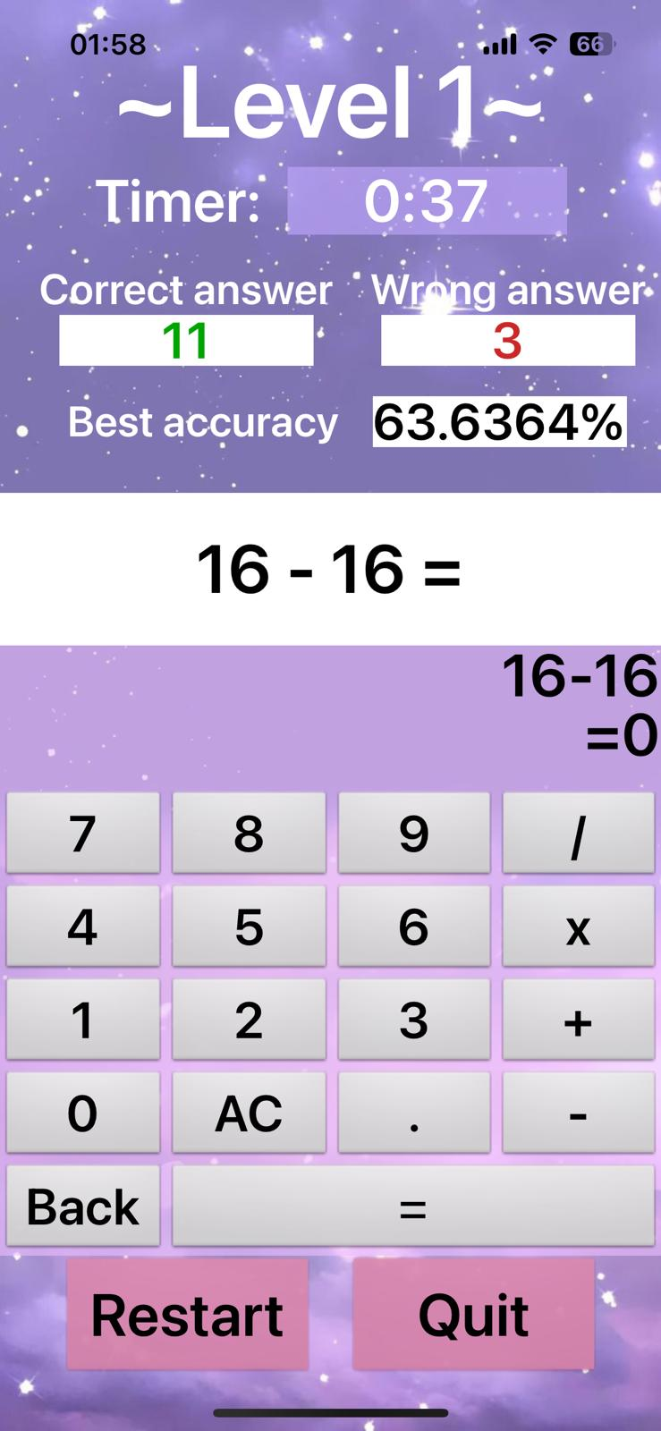 There is also a Help button, which will help the user solve the question by opening a calculator, during which the timer will stop. To return to the answer options, the Back button must be pressed. For Level 1, the calculator can only be used once.

Level 2 is similar to Level 1, the difference being the timer starting at 1:30, larger operands, and 2x computer access.

Level 3 consists of addition, subtraction, multiplication and division operations. Access to the computer is limited, and the answer must be entered on the keyboard and checked by pressing the Check button.

If you wish to use a calculator, when returning to the answer, the result from the calculator will be copied into the answer box.

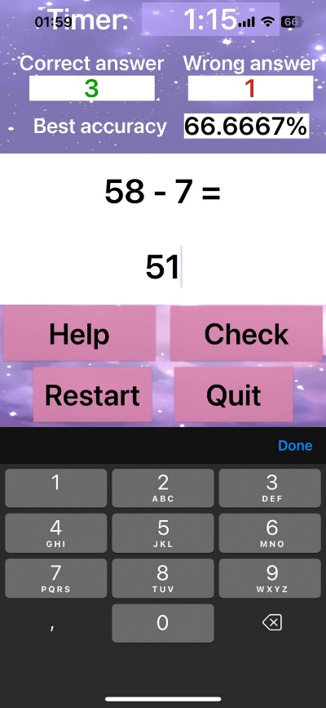

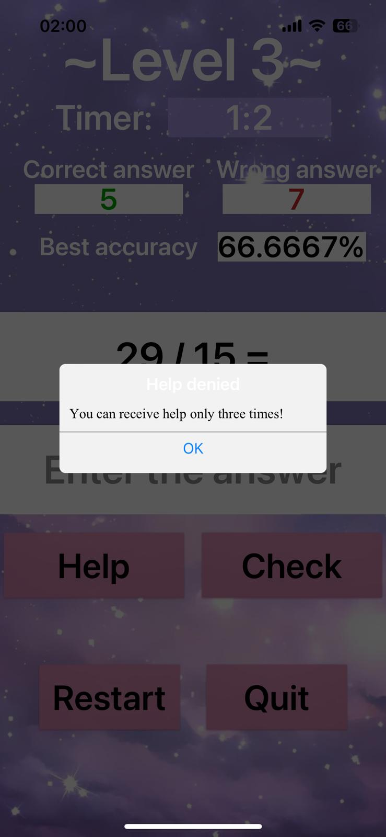

* **Sudoku**

Sudoku is a game consisting of 9 3x3 tables, and each table contains 9 3x3 squares that will need to be filled in by the user.

The rules of this game are simple. You must have numbers from 1 to 9 in each table, with no duplicates, and no more than one type of number is allowed in a row or column.

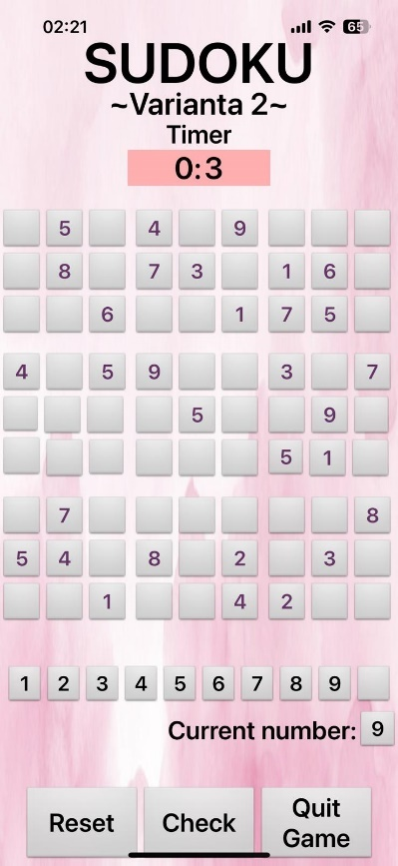When the game opens, a timer will start.

The game board consists of 9 tables with 3 rows and 3 columns each. Below this is a list of numbers, from 1 to 9, with which the board will be filled. When pressing one of these, the selected number will be displayed in the current number, then pressed in the board.

Pressing the Reset button will reset the game.

To return to the game list, press the Choose another Game button.

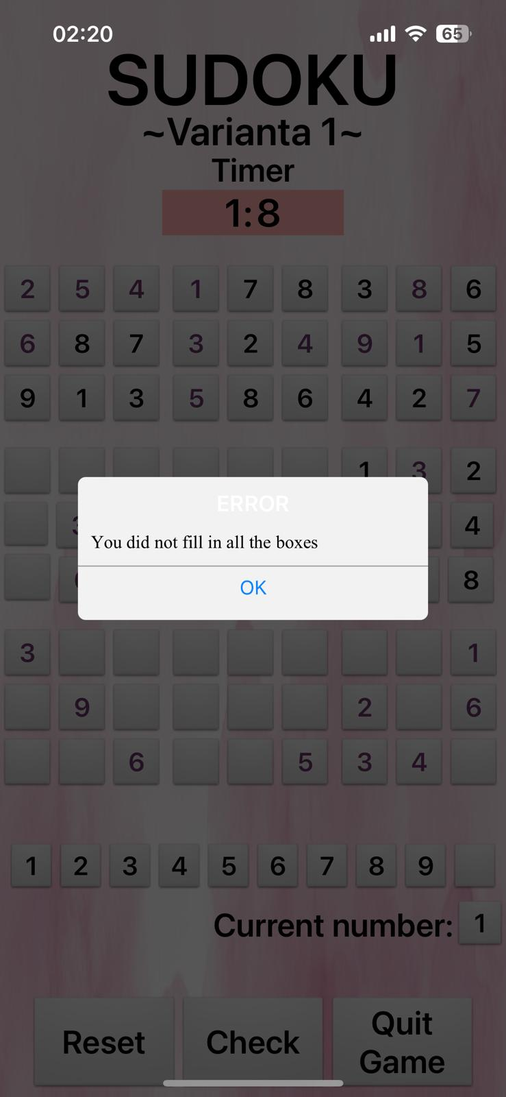

When you press the Check button, it will first check if all the free boxes have been filled in, otherwise a message will appear, and when you press the OK button you can return to completing the game board.

If all the boxes have been filled in, their correctness will be checked. If they are not all correct, a suggestive message will appear, and by pressing the Try again button you will be able to go back and change what you did wrong. Also, each correct answer will have green text, and the wrong one will have red text.

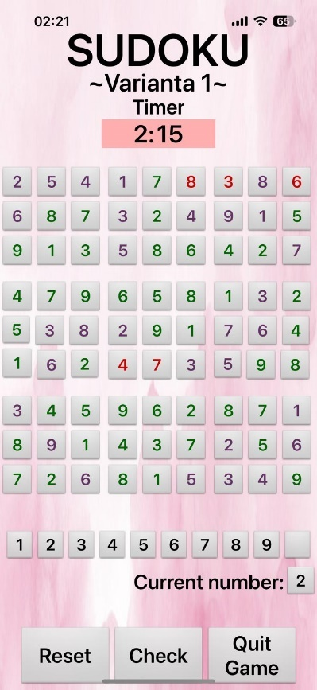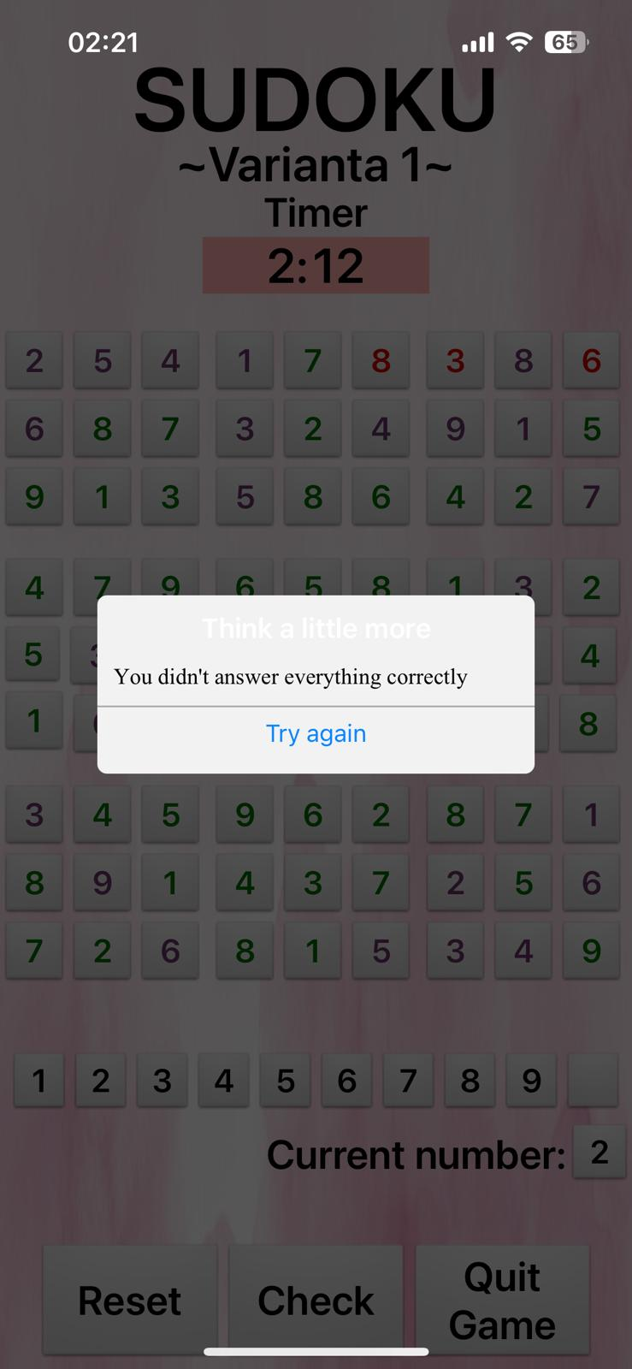

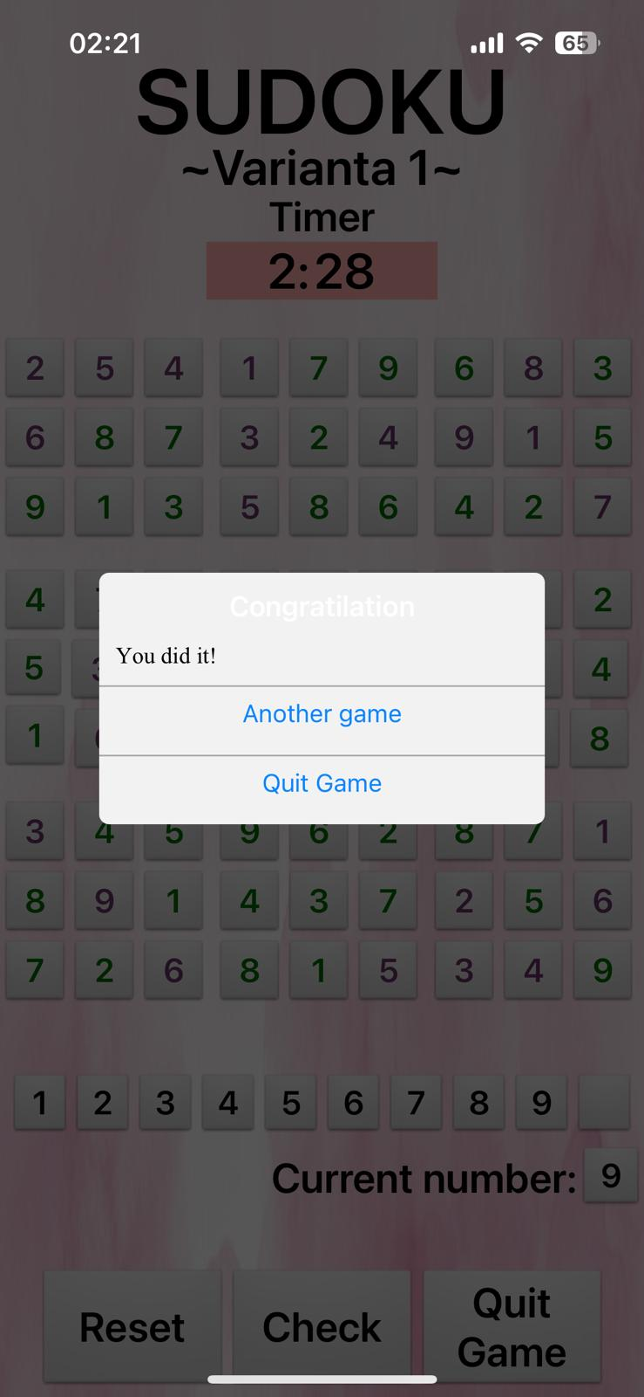

After you have filled in all the boxes correctly, a message will appear, and pressing the Another game button will reset the game, and pressing the Quit Game button will return the user to the game list.

* 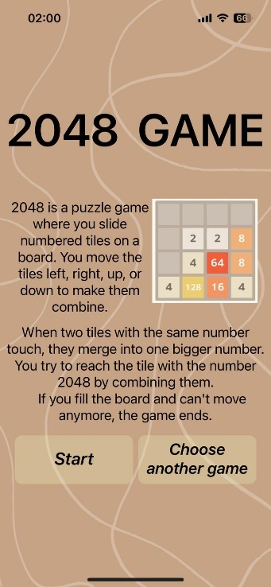**2048 Game**

When opening the game, the first page contains some information about the game, and the Start buttons which, when pressed, will open the game itself, and Choose another Game which will return the user to the list of games.

After pressing the Start button, the game opens.

The game board consists of 16 buttons, being a 4x4 table.

It contains the current score, which will be calculated as the sum of 2 digits that are the same and after moving end up next to each other, and the highest score obtained.

When you open the game, 2 blocks will appear, and by dragging your finger on the screen, they will move, making other blocks appear, and if there are 2 blocks with the same number next to each other, after moving, they will merge.

If the maximum of 2048 is reached or no more moves can be made on the board, then the game will be over, with the GameOver image appearing.

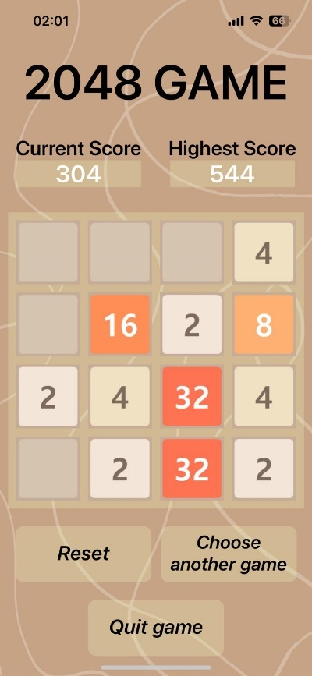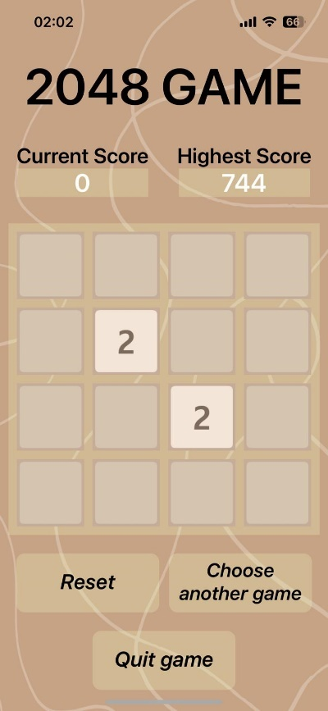

When you press the Reset button, the game will reset, clearing the game board and setting the current score to 1.

When you press the Quit Game button, a message will appear to confirm the game closure, and if the current score is higher than the Highest Score, then it will take its place.

When you press the Choose another Game button, you will return to the list of games.

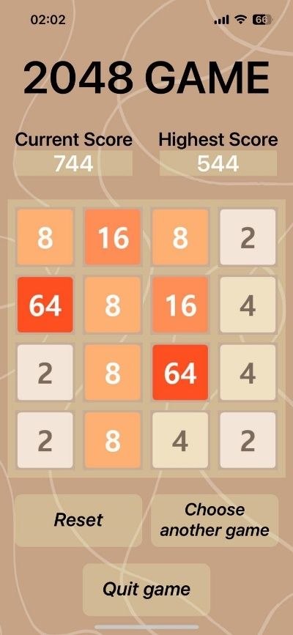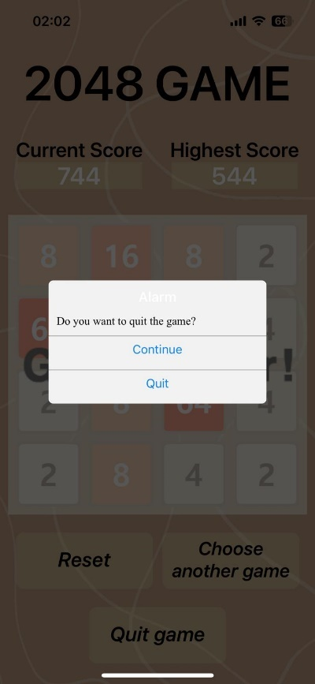

* 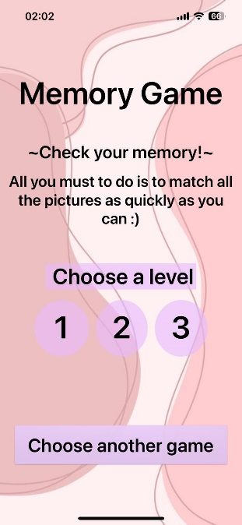**Memory Game**

This game is designed to test your memory.

The first page contains a brief description, and offers the possibility of choosing a level by pressing buttons 1, 2 or 3. If you wish to leave the game, press the Choose another Game button.

Each level has a timer that starts from 0, a score, which indicates the number of matching pairs out of the total number of pairs (3, 4 or 6) depending on the chosen level, and a BestTime, which contains the best score obtained by a player to date.

The game board consists of 6, 8 or 12 images, depending on the level chosen.

2 images are chosen one by one, displayed, and if they are not the same they will be turned over, and if they are the same, the score increases and the images will remain displayed, unable to be pressed again.

When you press the StartReset button, the timer will start from 0, the score will become 0 and all images will be flipped.

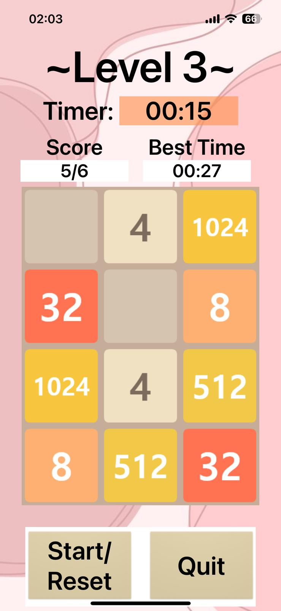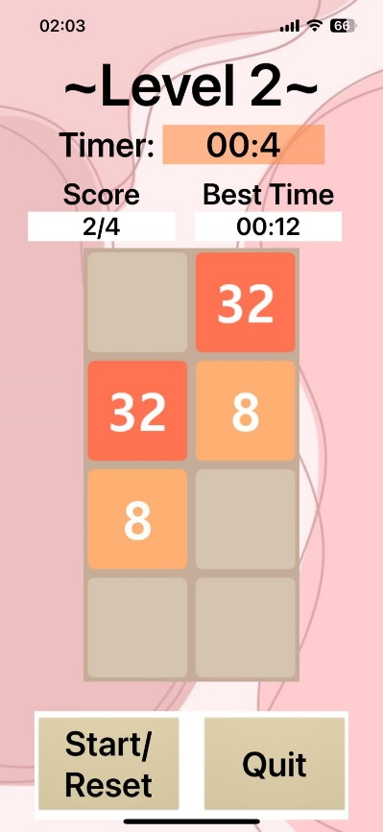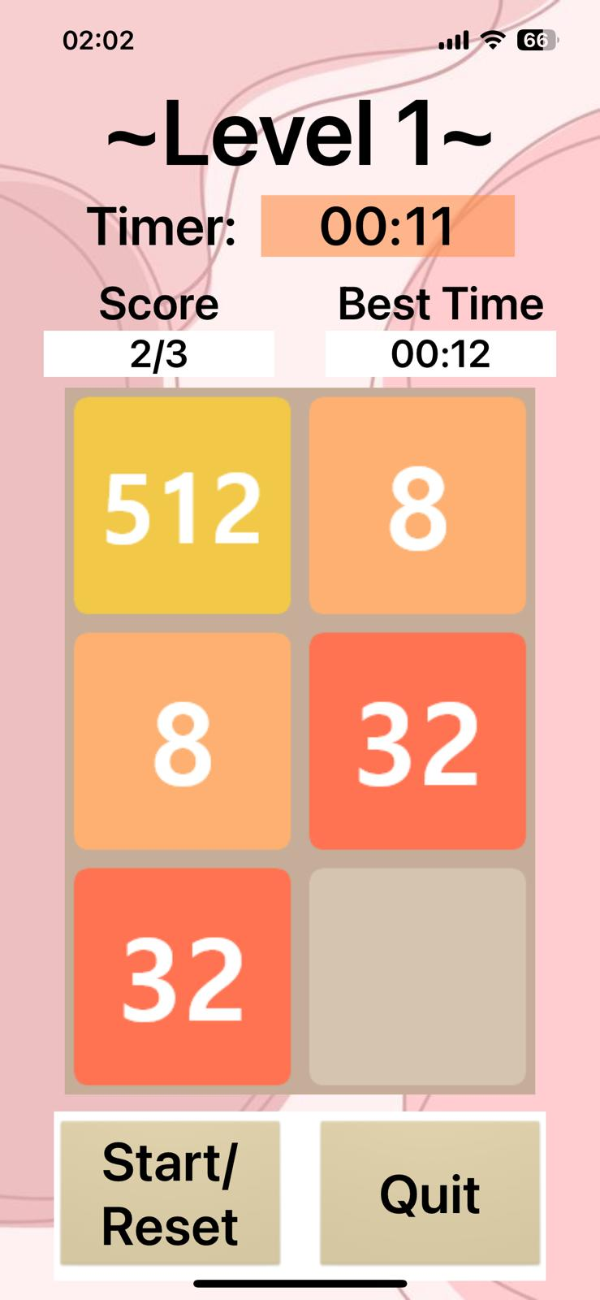

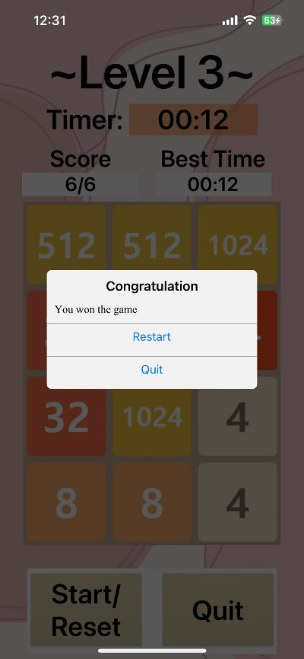

If all pairs of images have been found, a congratulatory message will appear, and by pressing the Restart button, the level will restart, and by pressing the Quit button the user will be able to choose another level for this game.

If you want to return to choosing another level, press the Quit button.

1. **References**
2. <https://community.appinventor.mit.edu/>
3. Courses + labs
4. https://appinventor.mit.edu/explore/ai2/tutorials